BUSINESS PLAN

JANUARY 2024

WEB APPLICATION

“KIDOFONICS”

**ABOUT INITIATOR OF THE PROJECT**

The initiator of the project is Saara Hanganeni Shaumbwako

An expert in the field of education in English and mathematics after 13 years teaching experience (2007-2020). I have tremendous experience of tteaching in a special school (School for the Visually Impaired).

A lawyer by profession too and admitted in the High Court of Namibia and currently working as a legislative drafter at the Ministry of Justice (Windhoek-Namibia).

I have an interest in the Information Communication Technology especially in area of cybersecurity. For that reason, I need to learn about computers (computer basics and how they operate) so as to understand them better.

The idea came up after joining the UNITAR course which is a Japan-funded Programme on "Developing Essential Digital Skills for Women and Youth in Africa: Enhancing Employment Opportunities and Livelihood Development in the Digital Economy"

**Competence**

One of the challenges faced during the early stages of schooling in a child’s life is learning to read. It is for this reason that the lower grades teaches children how to read by introducing them to phonics. Knowledge on how to make learning reading easier with the help of different methods as well.

I put forward the idea of creation web application “KIDOFONICS” which will become a necessary tool and assistant for a modern learner.

Try to incorporate a few Grade 1-3 reading content after a while. (Namibia children authors)

SUMMARY

The relevance of this idea:

In the present time, everything moves to the iinternet. This global network has captured absolutely all areas and eeducation is no exception. Modern technologyy progresses every year and are developing at a speedy pace. Most people, including children these days have smartphones and computers that provides instant access to the internet and the use of any available services. Children are the audience that grasps new technologies much faster than adults. Having an experience in working with children with visual impairments and every day faced with the problem of mastering reading which is a great essential of the learning process, I propose the idea to create a convenient and adapted for children web application "Kidofonics" "Kidofonics" is about ease of use, about a *"fashionable" device meant to teach children phonics and to better their reading skills.*

MARKET ANALYSIS

**GEOGRAPHY OF THE PROJECT**

The plan for the introduction of the application is the market, first of all, Namibia, and the rest of the countries that uses similar reading techniques as Namibia, for English-speaking students.

Audience Schoolchild 7-10 years, learners Initially, the application will be created in English, in the process of development it is planned to introduce other languages in Namibia. This will ensure that visually impaired children in SADC countries that struggles to grasp reading at an early stage of their live. The "Kidofonics" application will be aimed at the modern learner, no matter what country he is in.

SWOT ANALYSIS

|  |  |
| --- | --- |
| ADVANTAGES  1. Large audience  2. Helping children learn phonics  3. Lack of serious competition  4. Low project budget  5. Distance learning during free time | DISADVANTAGES  1. Probable system errors |

|  |  |
| --- | --- |
| Perspectives(read more)   1. Constant introduction of new features. 2. Introduction of manuals for preparation for App. | Threats  1. Refusal to purchase application renewal  2. New competitors |

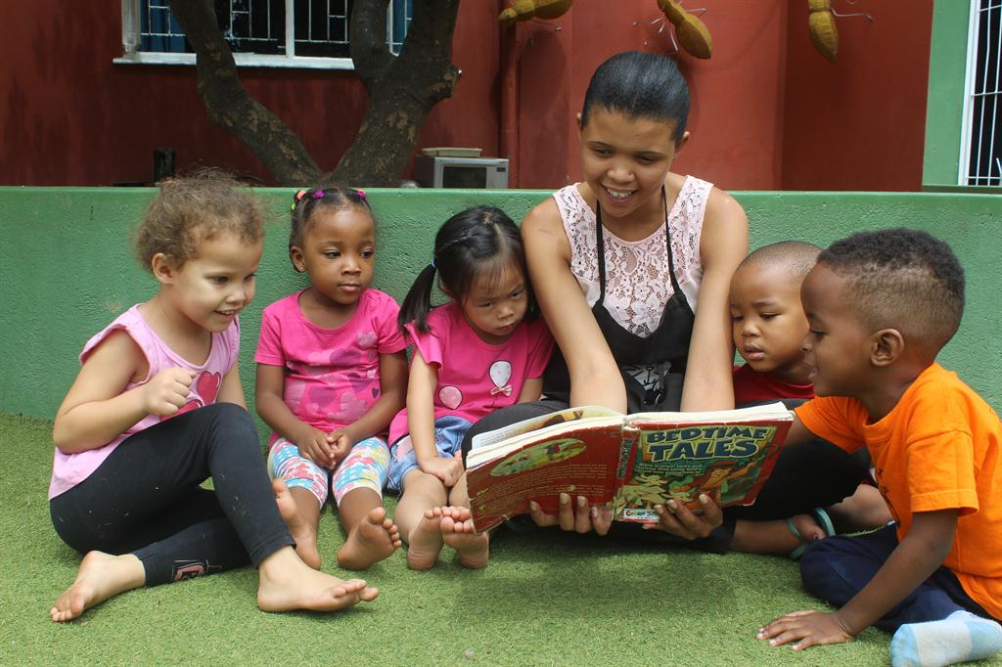

CONSUMER ANALYSIS

Analyzing consumers of a mobile application

we get the following data.

Children 7- 10 years old – average grades 1-3 school learners. Based on personal experience, 75% of children do not fully understand phonics. Since reading is essential in order for learners to grasp other subjects in schools children need to learn and accumulate knowledge in this area.

COMPETITOR ANALYSIS

No competitors at present in Namibia.

According to Census statistics at the time of 2023, there are many children who are visually impaired. There is a huge market and potential for the growth and development of a computer application.

“COMPETITION IS THE FUEL THAT IGNITES INNOVATION.” – SIMON SINEK.

APPLICATION LAUNCH

FINANCIAL PLAN

From a financial point of view, we have the following data: LIST PRICE (NAMIBIA DOLLARS)

Application development 168 000

Tutorial 12 600

Screenwriter 105 000

Advertising (for 1 year) 50 400

Technical costs (per year) 4200

PROJECT BUDGET

245 700 (NAMIBIA DOLLARS)

**Inclusion of PWDs and Underserved Communities**

Name: KIDOFONICS

Description

A device that teaches blind children/visually impaired learners with phonics. A device that when a letter of the alphabet is felt, a sound comes out (phonics sound) Have a screen /part where the alphabet can be felt on a Computer .

The braille alphabet:

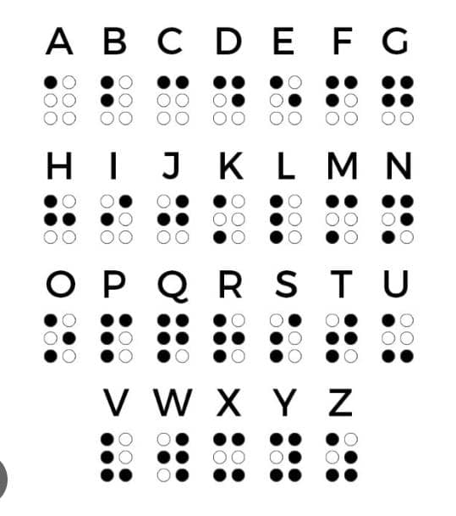

The phonics(sound) with example:

Phonics English letter words:

https://youtube.com/shorts/tfWdLXP_AWM?feature=shared

BEST REGARDS

SAARA HANGANENI SHAUMBWAKO